# Solution Report

**Team:** Alessio, Luca, Paolo

(**note**: while all listed page limits are recommendations, and not absolute restrictions, we do ask that you adhere to them as best you can)

## Part 1: Architecture and use

**Architecture**

Please provide a diagram illustrating the system architecture and briefly explain its components.

*Text/diagram(s) 1 page*

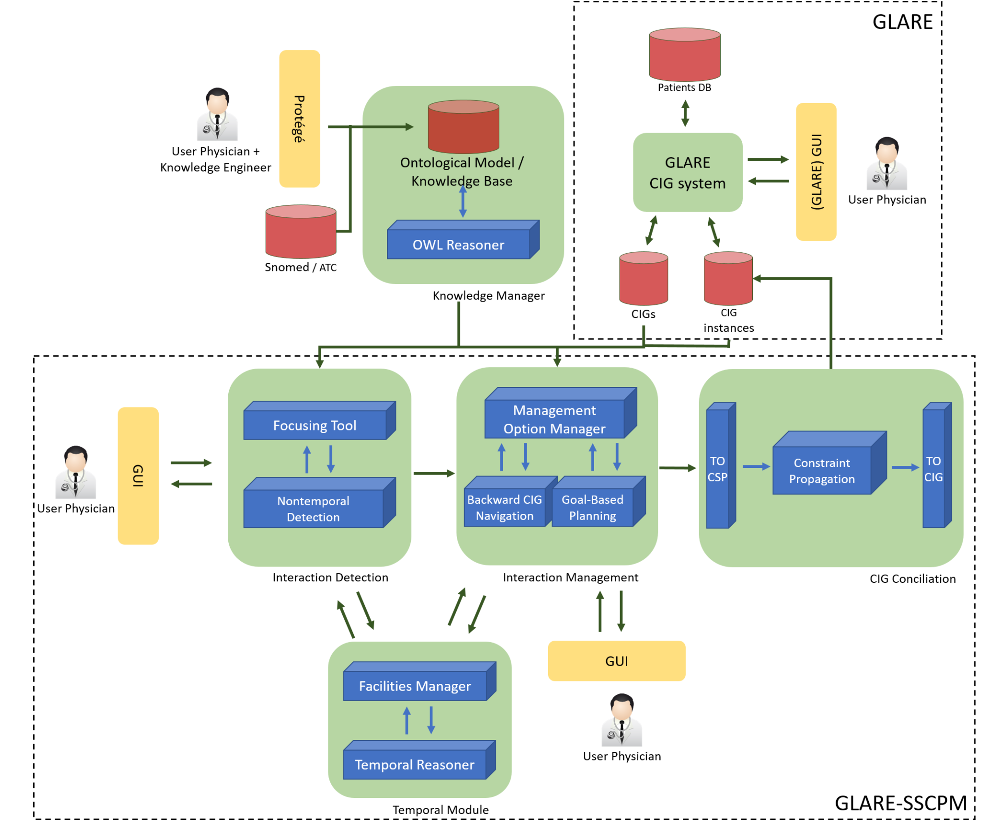

Figure 1. GLARE-SSCPM Architecture

The architecture of *GLARE-SSCPM* [[1]](https://www.zotero.org/google-docs/?xAW4Md) is shown in Figure 1. Basically, it has been designed to interact with a framework supporting CIG execution (in our case GLARE) and a *Knowledge Manager*, representing basic medical knowledge about CIG actions, drugs and interactions between their effects/intentions. GLARE-SSCPM is highly interactive with the user physician, and it is composed of four main modules:

(i) the *Interaction Detection* module [[2]](https://www.zotero.org/google-docs/?LWYOZe) provides a flexible and interactive focusing tool allowing physicians to navigate through the different abstraction levels of the CIGs, and to automatically detect interactions between focused actions, exploiting the Knowledge Manager;

(ii) the *Interaction Management* module [[3]](https://www.zotero.org/google-docs/?i0EDsY) supports physicians in the management of the detected interactions. Each interaction can be managed by selecting one of the eight *management options* defined in GLARE-SSCPM (and eventually extendible with new ones). Management options are “general ways” to manage interactions, taken from the medical literature, defined as modifications of the original CIGs obtained using the output of some reasoners (see [[3]](https://www.zotero.org/google-docs/?A4wrei)), the Knowledge Manager and the interaction with the user physician. For each interaction, the Interaction Management module drives physicians in the instantiation of the selected option on the specific CIG instances;

(iii) both the Interaction Detection and the Interaction Management modules are supported by a *Temporal Reasoner* module, providing several temporal facilities [[2]](https://www.zotero.org/google-docs/?QdTdWX);

(iv) finally, the CIG Conciliation module [[4]](https://www.zotero.org/google-docs/?nKaTwe) performs a “merging” step that propagates the constraints introduced during the management phase along the involved CIGs and guarantees that the CIGs are concurrently executable.

**CIG representation**

Please explain the formalism used to represent CPGs.

META-GLARE [[5]](https://www.zotero.org/google-docs/?yj91JA) is a “meta-system” for CIGs, or, in other words, a shell supporting the definition (or modifying) of new CIG formalisms and systems. Roughly speaking, the input of META-GLARE is a description of a representation formalism for CIGs, and the output is a new system able to acquire, represent, consult and execute CIGs described using such a formalism.

META-GLARE supports the GLARE representation formalism [[6]](https://www.zotero.org/google-docs/?zcnUvc). The CIGs are represented as hierarchical graphs. The nodes represent actions or decisions and the arcs model the control flow relations and the temporal constraints between them. GLARE distinguishes between the following types of actions:

* *atomic actions* (simple steps in a CIG), Atomic actions can be:
  + *work actions* a procedure which must be executed, represented graphically by a blue circles
  + *query actions* retrieval of information from the clinical record/examinations represented graphically by green parallelograms
  + *decision* actions choice among different alternatives, represented graphically by yellow rhombuses . GLARE supports two different types of decision: diagnostic decision and therapeutic decision.
  + *conclusion* actionsare outputs of decisions and the changes of patient state, represented graphically by orange triangles
* *composite actions* (plans), which are defined in terms of their components (thus supporting the definition of CIGs at different levels of abstraction) and are represented graphically by red octagons.

*GLARE* formalism has different control flow relations:

* *sequence* relation (graphically represented by an oriented arc) between two actions A and B states that A and B must be executed in sequence, i.e. the execution of B can only begin after the end of the execution of A*.*
* *alternative* relation (graphically represented by oriented arc) applies to a decision action D and to n actions A1,…,An of any type (composed or atomic; n>0) representing the fact that one of the n actions A1,…,An is executed depending on the results of the execution of the decision action D
* *controlled relation* (graphically represented by a double no-oriented arc) between two actions A1 and A2 states that they can be executed in any order, or also in parallel: the concurrent action fails if any of A1, A2 fails. A1 and A2 can start in any order, and the concurrent action ends when both A1 and A2 end. Obviously the concurrency relation can be applied to 3 or more actions.

Every type of action has an internal representation based on a specific set of attributes. For example, decision actions embody the criteria which can be used to select from alternative paths in a guideline. In particular, diagnostic decisions are represented as an open set of triples diagnosis, parameter, score (where, in turn, a parameter is a triple data, attribute, value), plus a threshold to be compared with the different diagnoses’ scores.

GLARE formalism allows one to represent the (minimum and maximum) duration of each action. Temporal constraints can also be associated with control relations between actions. In the sequence and alternative relations, it is possible to indicate the minimum and/or maximum delay between actions. In a controlled relation, one can specify the minimum and/or maximum distance between any pair of endpoints of the actions involved (i.,e. the start and the end of the action). On the basis of such distances, one can express both qualitative constraints between actions (however, only continuous pointizable relations can be coped with [23]) and quantitative ones.

Finally, two different ways of specifying repetitions are defined (and can be combined):

* one can state that the action has to be performed until a given exit condition becomes true,
* one can specify duration (frame time) for the repetitions.

In both cases, the frequency of the repetitions in time has to be specified as well; then, several other temporal parameters must/can be provided (see for details [[7]](https://www.zotero.org/google-docs/?gnNzKd).

Additionally, (and optionally) the formalism may indicate the ontologies (e.g., SNOMED) it adopts to provide ontological references as values of (some) attributes of nodes/arcs. Notably, different ontologies may be pointed out (e.g., SNOMED for findings and actions, ATC for drugs).

**Domain knowledge representation**

If additional domain knowledge is required, please explain how it is represented. Indicate whether standards (e.g., SNOMED-CT, FHIR, standard domain ontologies) are being utilized.

*Text/diagram(s) ½ page*

In the GLARE-SSCPM approach, we distinguish between domain-specific knowledge in the CIGs and general medical knowledge (GMK), i.e., the “deep” knowledge underlying medical reasoning. Our Knowledge Manager module manages such a “deep” knowledge as an OWL ontological model representing actions, their effects and their intentions (goals), and the interactions between such elements. Effects and intentions are expressed as variations of patient’s status. Each variation (e.g., the “Anticoagulant” one) relates to exactly one attribute (“blood coagulation status”), describing the patient’s status, and to exactly one modality of the variation (“decrease”). The ontological model, besides describing the actions, provides a representation of the possible interactions. In particular, four classes of interactions exist: *Variation interactions* represent interactions between the effects of two actions; *Intention interactions* are the ones involving at least an intention of an action; *Drug interactions* involve the drugs prescribed by pharmacological actions and *Status interactions* are the ones between an effect of an action and the status of a patient. As detailed in the hierarchy proposed in [[3]](https://www.zotero.org/google-docs/?YKew2w), Intention interactions are a particular case of Variation interactions, and interactions can be caused by other interactions. Each interaction can have a type, which can be “*Concordant*” if the interaction strengthens one (or more) of the involved elements, or “*Discordant*” if it weakens one of the elements. Elements that do not interact are defined as “Independent”. Further refinements are possible, for instance “*Opposite*” (refining the type “Discordant”) is used for (variation) interactions in which elements are focused on the same attribute, with different modalities (increase/decrease). Techniques to automatically infer such interactions are provided (see below). However, for the sake of completeness, some of them can be manually inserted in the knowledge base (e.g., by loading them from external repositories). Similarly, the general knowledge of the ontological model can be acquired from medical literature or, in part, imported by well-known standard repositories (e.g., SNOMED for medical actions and ATC for drug taxonomy).

In [[2]](https://www.zotero.org/google-docs/?5lfvJu),the ontological model has been extended with temporal information about the delays between the starting/ending of an action and the starting/ending of its effects (or, alternatively, the duration of the effects), and for intentions the time in which they should occur within the CIG execution. Since this kind of information tends to be temporally indeterminate (i.e., one cannot predict the exact delay between the starting of an action and the occurrence of its effects) a representation of temporal indeterminacy was adopted.

**Reasoning about deep knowledge**

Knowledge-based detection of interactions is performed by rule-based OWL reasoning [[8]](https://www.zotero.org/google-docs/?GEbwK4). Given two actions, the reasoner exploits the ontological model to infer all the possible interactions between the effects, the intentions and the drugs related to the two actions. For instance, for the two actions “Warfarin therapy for AFib” and “Aspirin therapy for CKD”, the reasoner first retrieves, from the ontological model, all the effects/intentions/drugs associated to such actions. Among them, the variations “Anticoagulant” and “Prevent cardiovascular diseases” are found. Due to the causal relationship between them, the interaction “Pcd-Anticoag Interaction” is automatically asserted by the reasoner. The above interaction detection is, however, abstract if not paired with a temporal analysis. Indeed, the detected interactions highlight the fact that the involved actions can potentially interact. However, actions actually interact only if their effects, intentions or drug administrations overlap in time. For such a reason, the Temporal Reasoner module, which is based on an extension of the STP (Simple Temporal Problem) framework, provides a set of facilities to analyze interactions also considering time. In particular, given two actions, their execution times and the temporal information provided in the ontological model, the Temporal Reasoner exploits temporal reasoning techniques to detect whether:

* the two actions could hypothetically interact, but they actually do not interact considering their times of execution (in case the interacting effects/intentions/drug administrations do not overlap in time);
* the two actions can potentially interact considering their execution times (in case the interacting effects/intentions/drug administrations could probably overlap - considering temporal indeterminacy);
* the two actions certainly interact (in case the interacting effects/intentions/drug administration certainly overlap in time).

**Mode of use**

Please explain the intended mode of use of the system: who are the intended end-users, when is the system to be used: during patient encounter, real-time vs. simulation, etc.

*Text/diagram(s) ½ page*

GLARE-SSCPM supports user physicians in the real-time or simulated treatment of comorbid patients. GLARE-SSCPM is characterized by a high degree of interaction with user-physicians, to interactively support, “step-by-step”, their decisions. In particular, in a working session using GLARE-SSCPM, three main tasks are supported:

(i) FOCUSING AND DETECT: a physician can interactively focus on the parts of the CIGs that are relevant to the current status of the patient, and ask it to automatically detect the possible interactions between the focused actions by exploiting the facilities provided by the Knowledge Manager module and by the Temporal Reasoner;   
(ii) MANAGEMENT: GLARE-SSCPM provides user-physicians with eight general management options for solving each detected interaction, giving them a way of simulating the application of each option. All the management options are achieved on top of three basic reasoning techniques: Backward Navigation on the CIGs, Goal Based Planning (taking advantage of the Knowledge Manager and of its Knowledge Base), and Temporal Reasoning (see Table 1).

Table 1. Reasoning techniques adopted to support management options.

|  |  |  |  |  |  |  |  |
| --- | --- | --- | --- | --- | --- | --- | --- |
| Safe alternative | Replanning | Temporal avoidance | Dosage adjustment | Effect monitoring | Interaction mitigation | Interaction alignment | Intention alignment |
| NAV | GBP+TR | TR | other | GBP+TR | GBP+TR | NAV+TR | GBP+TR |

The application of the options is based on the mixed-initiative strategy: options have been designed to allow user physicians and the tool to collaborate in such a task. The process ends when an option is chosen by the physicians.   
(iii) CONCILIATION/MERGING: finally, in case multiple interactions have been managed, GLARE-SSCPM automatically checks the general consistency of the chosen management. In the case of consistency, it provides a “merge” of the (focused parts of the) CIGs, while, in the case of inconsistency, physicians may check alternative managing options (following the “hypothesize and test” methodology).

**Strengths of the approach**

Does the approach have very good support for particular features? Which? Please justify. What is the singular point of strength of your approach?

*Text/diagram(s) ½ page*

1. Generality. GlareSSCPM is general in the sense that:
   1. it operates on any set of CIGs (acquired in GLARE), and
   2. it supports interaction detection and management on the basis of general “deep” knowledge (i.e., declarative knowledge independent of specific CIGs and interactions) and general reasoning techniques (e.g. planning, temporal reasoning)

The main advantages of generality are issues 2 and 3 below.

1. when the interactions between a new set of CIGs has to be considered, the system simply exploits the new CIGs and the pre-existent “deep” knowledge, without forcing physicians to
   1. elicit possible interactions between CIGs, and\or
   2. elicit the specific managements of such interactions.
2. interactions and their possible managements can be explained to user-physicians on the basis of “deep” knowledge.[1]
3. Mixed-initiative. While GLARE-SSCPM supports fully automated interaction detection, it supports mixed-initiative treatment of detected interactions. Specifically, GLARE provides user-physicians with focusing facilities, and supports an hypothesize-and-test methodology for interaction management.
4. All the features are supported, except C2 (and, partially, A4 and B5 - see below).
5. Temporal reasoning. Since interactions occur in time, specific attention is devoted to the treatment of the temporal dimension. Recent extensions also involve the possibility of representing and reasoning with temporal preferences and temporal probabilities (see, e.g., [[9]](https://www.zotero.org/google-docs/?GiZh3s)).
6. GLARE-SSCPM is designed to be paired with a standard CIG executor (such as GLARE). As a consequence, all the facilities provided by the CIG executor can be still exploited for comorbid patients.

### REFERENCES

[[1] L. Piovesan, P. Terenziani, and G. Molino, “GLARE-SSCPM: an Intelligent System to Support the Treatment of Comorbid Patients,” *IEEE Intelligent Systems*, 2018, doi: 10.1109/MIS.2018.111144734.](https://www.zotero.org/google-docs/?TgGLgJ)

[[2] L. Anselma, L. Piovesan, and P. Terenziani, “Temporal detection and analysis of guideline interactions,” *Artif. Intell. Med.*, vol. 76, pp. 40–62, Feb. 2017, doi: 10.1016/j.artmed.2017.01.001.](https://www.zotero.org/google-docs/?TgGLgJ)

[[3] L. Piovesan and P. Terenziani, “A Mixed-Initiative approach to the conciliation of Clinical Guidelines for comorbid patients,” in *KR4HC 2015*, vol. 9485, Pavia: Springer International Publishing, 2015, pp. 95–108.](https://www.zotero.org/google-docs/?TgGLgJ)

[[4] L. Piovesan and P. Terenziani, “A Constraint-Based Approach for the Conciliation of Clinical Guidelines,” in *Advances in Artificial Intelligence - IBERAMIA 2016*, Nov. 2016, vol. 10022, pp. 77–88. doi: 10.1007/978-3-319-47955-2_7.](https://www.zotero.org/google-docs/?TgGLgJ)

[[5] A. Bottrighi and P. Terenziani, “META-GLARE: A meta-system for defining your own computer interpretable guideline system—Architecture and acquisition,” *Artificial Intelligence in Medicine*, vol. 72, pp. 22–41, Sep. 2016, doi: 10.1016/j.artmed.2016.07.002.](https://www.zotero.org/google-docs/?TgGLgJ)

[[6] P. Terenziani, S. Montani, A. Bottrighi, G. Molino, and M. Torchio, “Applying artificial intelligence to clinical guidelines: the GLARE approach,” *Stud Health Technol Inform*, vol. 139, pp. 273–282, 2008.](https://www.zotero.org/google-docs/?TgGLgJ)

[[7] L. Anselma, P. Terenziani, S. Montani, and A. Bottrighi, “Towards a comprehensive treatment of repetitions, periodicity and temporal constraints in clinical guidelines,” *Artificial Intelligence in Medicine*, vol. 38, no. 2, pp. 171–195, Oct. 2006, doi: 10.1016/j.artmed.2006.03.007.](https://www.zotero.org/google-docs/?TgGLgJ)

[[8] L. Piovesan, G. Molino, and P. Terenziani, “Supporting Physicians in the Detection of the Interactions between Treatments of Co-Morbid Patients,” in *Healthcare Informatics and Analytics: Emerging Issues and Trends*, IGI Global, 2014, pp. 165–193.](https://www.zotero.org/google-docs/?TgGLgJ)

[[9] P. Terenziani and A. Andolina, “Considering Temporal Preferences and Probabilities in Guideline Interaction Analysis,” in *Artificial Intelligence in Medicine - 17th Conference on Artificial Intelligence in Medicine, AIME 2019, Poznan, Poland, June 26-29, 2019, Proceedings*, 2019, vol. 11526, pp. 120–124. doi: 10.1007/978-3-030-21642-9_16.](https://www.zotero.org/google-docs/?TgGLgJ)

[[10] L. Piovesan, P. Terenziani, and D. Theseider Dupré, “Conformance analysis for comorbid patients in Answer Set Programming,” *Journal of Biomedical Informatics*, vol. 103, p. 103377, Mar. 2020, doi: 10.1016/j.jbi.2020.103377.](https://www.zotero.org/google-docs/?TgGLgJ)

[[11] L. Anselma, “Reasoning and querying bounds on differences with layered preferences.,” *Int. J. Intell. Syst.*, vol. 36, no. 5, pp. 1998–2035, 2021, doi: 10.1002/int.22369.](https://www.zotero.org/google-docs/?TgGLgJ)

[[12] L. Piovesan, “A Mixed-Initiative Knowledge-Based Decision Support Methodology for the Management of Patients affected by Comorbidities,” Ph.D. thesis, University of Turin, 2016.](https://www.zotero.org/google-docs/?TgGLgJ)

[[13] P. Terenziani and A. Andolina, “Probabilistic quantitative temporal reasoning,” in *Proceedings of the Symposium on Applied Computing, SAC 2017, Marrakech, Morocco, April 3-7, 2017*, 2017, pp. 965–970. doi: 10.1145/3019612.3019712.](https://www.zotero.org/google-docs/?TgGLgJ)

Part 2: Features

Section A outlines a set of features that relate to possible interactions among advice offered by CPGs. Section B lists a set of features that relate to possible mitigation strategies for these interactions.

Section C lists other possible features. We include a brief example to illustrate each feature.

For each of the features, please indicate whether it is supported, and, if so, briefly explain how.

### Section A. Interactions among CPGs’ advice

**A1**: Drug from a CPG has an effect on a comorbid condition

*For example, low-dose Aspirin (Cardiovascular Disease CPG) affects Duodenal Ulcer (comorbid condition).*

*Implemented (Y/N)*: Y

*Brief description*: the situation is detected by GLARE-SSCPM as a *status interaction* (see [[3]](https://www.zotero.org/google-docs/?GgLL4G)) between one (or more) of the effects of the given drug and the patient’s status attribute that models the comorbid condition. Consider, e.g., the status interaction between non-selective beta blockers (prescribed for the treatment of atrial fibrillation) and the “low” renal function status (given by the chronic kidney disease) described in [[10]](https://www.zotero.org/google-docs/?6ULSld). The Interaction Detection module detects such an interaction because, in the ontological model, non-selective beta blockers cause, as effect, the decreasing of the glomerular filtration rate, an indicator for the renal function, which is already “low” in the patient’s status. In such a case, any management option can be applied to manage the interaction. In [[10]](https://www.zotero.org/google-docs/?MgSdwZ), for instance, the interaction has been managed with the *replanning* option: non-selective beta blockers have been replaced with selective beta blockers, that do not interact with the patient’s status.

**A2**: Two or more drugs from different CPGs interact

*For example, antibiotics such as Trimethoprim/Sulfamethoxazole impact the anticoagulant effect of Warfarin.*

*Implemented (Y/N)*: Y

*Brief description*: the situation is detected by GLARE-SSCPM as a *drug interaction* [[8]](https://www.zotero.org/google-docs/?cwfkyM), optionallycaused by the effects of the interacting drugs. Consider, e.g., the drug interaction between warfarin and amoxicillin described in [[2]](https://www.zotero.org/google-docs/?GwWwuM). The Interaction Detection module detects such an interaction because, in the ontological model, an interaction can be inferred between the “anticoagulant” effect of warfarin and the “antiplatelet'' one of amoxicillin, with both the effects that cause the effect “increase risk of bleedings''. Even if GLARE-SSCPM does not force physicians in the use of a specific management option, such an interaction can be managed by using a dosage adjustment option (i.e., with the decrease of the dosage of the warfarin) in conjunction with an effect monitoring one (by adding an INR monitoring action, to monitor the blood coagulation status).

**A3**: Clinical goals from different CPGs conflict

*For example, the goal of preventing thrombosis conflicts with the goal of preventing bleeding during surgery.*

*Implemented (Y/N)*: Y

*Brief description*: the situation is detected by GLARE-SSCPM as an *intention interaction* [[8]](https://www.zotero.org/google-docs/?8zj9Rb), i.e., an interaction between one or more intentions of the interacting actions. Even if GLARE-SSCPM does not force physician to select one of the following management options, the most suitable ones for such a situation are: (i) safe alternative, (ii) replanning, (iii) interaction mitigation (in case the interaction is undesired) or (iv) interaction alignment (in case the interaction is desired). In case (i), an alternative action/path in the CIG is selected (if any) to avoid the execution of one of the interacting actions. In case (ii), the Knowledge Manager is exploited to retrieve, from the knowledge base, an action (say C) with effects similar to the intentions on one of the interacting actions (say A), but not interacting with the other one (say B); then A is replaced with C in the original CIG. In case (iii), an action that mitigates the interaction is retrieved from the knowledge base, and it is added to the CIGs. In case (iv), interacting actions are moved in time to ensure that the interaction actually occurs.

**A4**: Conflicting actions (e.g., drugs, procedures) from different CPGs

*For example, one CPG recommends administration of Clopidogrel (Transient Ischemic Attack CPG) while another recommends suspending Clopidogrel (Coronary Artery Bypass Grafting CPG).*

*Implemented (Y/N)*: partially

*Brief description*:conflicting actions are detected by GLARE-SSCPM as interactions. In particular, interactions between actions with opposite effects/intentions have type “Opposite” and they can be managed through the following management options: “replanning”, “safe alternative”, “temporal avoidance”, “dosage adjustment”, “interaction mitigation”, “effect monitoring”. However, considering the specific example, GLARE does not support the direct representation in a CIG of an action suspending/deleting an action in another CIG (in GLARE, CIGs are strictly independent of each other). On the other hand, GLARE-SSCPM supports the suspension/deletion as a consequence of interaction management.

**A5**: Duplicate or redundant advice from different CPGs

*For example, Calcium Channel Blockers are recommended in Hypertension and Cardiovascular Disease CPGs.*

*Implemented (Y/N)*: Y

*Brief description*:the situation is detected by GLARE-SSCPM as an *interaction* of type “*Concordant*” and it can be managed with the option “intention alignment” (see, e.g., [[10]](https://www.zotero.org/google-docs/?MqO0vv)). In the case of intention alignment, the physician, with the help of GLARE-SSCPM, can “merge” two actions of two different CIGs into a single one, possibly respecting the temporal constraints of both CIGs, or to substitute them with a new action, which pursues the same (or similar) intentions of the two actions. This management modality actually corresponds to different submodalites: (i) the removal of one of the interacting actions (removeduplicate), (ii) the shortening of one of the two actions (shortenduplicate) and (iii) the removal of both the interacting actions, and their replacement with an action achieving all their intentions (removeboth). Consider, e.g., the (multiple) interactions between the different prescriptions of ACE inhibitors in [[10]](https://www.zotero.org/google-docs/?JqWz3g): acei_htn2 prescribed for hypertension in the interval of days [84,167], acei_afib prescribed for cardiovascular disease in [132,∞], acei_ckd prescribed for kidney disease in [160,∞]. In such a case, the user physician can decide to remove (removeduplicate) acei_ckd because of the inclusion in the interval of acei_afib, and then to postpone the starting of acei_afib (shortenduplicate) because of the partial overlap with acei_htn2.

**A6**: Temporal relationship between different CPGs

*For example, take Cefpodoxime (Acute Otitis Media CPG) two hours after taking antacids (Gastroesophageal Reflux Disease CPG).*

*Implemented (Y/N)*: Y

*Brief description*:the situation is detected by GLARE-SSCPM as an interaction between the two actions. The interaction type depends on the elements involved in the interaction (effect, intention, drug, see above). The applied management option depends on the desirability of the interaction. If the interaction is desired (e.g., the interaction enforces the intention of one of the interacting actions), the interaction alignment option can be applied. With interaction alignment, the interaction can be forced by maintaining the interacting actions and (using the temporal reasoning facilities of GLARE-SSCPM) by executing them in times such that the interaction occurs. On the contrary, if the interaction is undesired, the temporal avoidance option can be applied. In such a case, using the temporal reasoning facilities, interacting actions are moved at times such that their interacting effects/intentions/drugs cannot overlap in time.

**A7**: Multiple interactions from different CPGs interacting at the same time

*For example, replacing low-dose Aspirin (Transient Ischemic Attack CPG) with Proton Pump Inhibitor to mitigate Duodenal Ulcer (Duodenal Ulcer CPG) impacts new comorbid condition of Osteoporosis (Osteoporosis CPG).*

*Implemented (Y/N)*: Y

*Brief description*:GLARE-SSCPM supports (with the same tasks described above) the detection and management of multiple interactions, even in the case of actions introduced for the management of an interaction. First, each interaction is detected and managed in isolation (as described above) taking advantage of the facilities provided by the Interaction Detection and Interaction Management modules. Then, the Conciliation module [[4]](https://www.zotero.org/google-docs/?HLBlMa) propagates the constraints introduced for the individual managements and verifies the consistency of all the obtained CIG instances. If the obtained result is consistent, the Conciliation module updates the CIG instances according to the propagation (see [[4]](https://www.zotero.org/google-docs/?DymvtZ)). Otherwise, the module reports an error. Errors can be due to an inconsistency (i.e., there is no possible execution of the CIGs consistent with all the constraints introduced for interaction management) or due to the restriction of an “uncontrollable” element (e.g., a diagnostic decision, which in GLARE depends only on the patient’s status). In the case of errors, the Conciliation module supports physicians in the revision of the applied managements, in order to avoid inconsistency.

### Section B. Mitigation strategies when CPGs offer interacting advice

A mitigation strategy is an action taken to address one or many of the interactions that were identified above.

**B1**: Adding a drug to mitigate an adverse effect

*For example, add a PPI to mitigate the Duodenal Ulcer due-to Aspirin.*

*Implemented (Y/N)*: Y

*Brief description*:the situation is managed with the “interaction mitigation” management option. First, The Knowledge Manager is used to find a “mitigating” action (or plan) with an interaction “Opposite” (or “Discordant”) with respect to the effect of the managed interaction. If multiple choices are available, GLARE-SSCPM asks the user physician to select one of them. Then, the Temporal Reasoner is exploited to determine the temporal constraints of the mitigating action such that the effects of the mitigating action occur during the managed interaction. Consider, e.g., the case described in [[4]](https://www.zotero.org/google-docs/?D7B3mV). To manage the interaction between warfarin (in the CIG for venous thromboembolism) and amoxicillin (in the CIG for peptic ulcer), the “replanning” option was applied and aspirin was added to replace warfarin. However, aspirin interacts with peptic ulcer by increasing gastric acidity and, consequently, ulcer. To manage such an interaction, “interaction mitigation” was selected and drugs decreasing gastric acidity were proposed to the physician. Among them, she selects omeprazole, which was added to the CIGs with temporal constraint ensuring its recommendation during all the aspirin treatment.

**B2**: Adjust drug dosage

*For example, a reduction of 10% of warfarin dosage.*

*Implemented (Y/N):* Y

*Brief description*:the situation is managed with the “dosage adjustment” management option. With such an option, GLARE-SSCPM considers the effect of the interaction and then it suggests an adjustment of the drug dosage opposite with respect to the variation caused by the interaction (i.e., an increase of the dosage in case of decreased variation and vice versa). For instance, in the concurrent administration of warfarin and certain antibiotics, an interaction is detected causing an increase in the effects of warfarin. As a consequence, if the physician decides to manage such an interaction through the “dosage adjustment” option, GLARE-SSCPM suggests her to reduce the dosage of warfarin.

**B3**: Monitor the effect of a drug

*For example, monitor progression of the Duodenal Ulcer during overlapping treatment with Aspirin.*

*Implemented (Y/N)*: Y

*Brief description*:the situation is managed with the “effect monitoring” management option. In GLARE-SSCPM, such an option does not manage status interactions only (such as in the example), but it can be used to manage each kind of interaction. To apply such an option, first the Interaction Manager module considers the effect(s) of the interaction. Then, exploiting the Knowledge Manager, it retrieves from the knowledge base one or more query actions that focus on the effect(s) of the interaction. If multiple choices are available, GLARE-SSCPM asks the user physician to select one of them. Then, the Temporal Reasoner is exploited to determine the temporal constraints of the query actions such that they are executed during the occurrence of the interaction. Consider, e.g., the interaction between warfarin and erythromycin described in [[3]](https://www.zotero.org/google-docs/?C5Hi7f), increasing the (anticoagulant) effect of warfarin. In such a case, the Interaction Management module proposes a set of query actions focused on the blood coagulation status. Then, the user physician selects “INR monitoring”, which is added to the CIGs after the concurrent administration of the two drugs.

**B4**: Replacing a drug with a safer / non-interacting drug / more effective drug for comorbidity

*For example, replace Aspirin with Clopidogrel for a patient with Duodenal Ulcer.*

*Implemented (Y/N)*: Y

*Brief description*:the described situation can be managed in GLARE-SSCPM with two different management options: “safe alternative” or “replanning”, depending on the structure of the CIGs and on the knowledge modeled in GLARE-SSCPM. The “safe alternative” option can be applied when an interaction is detected before that the status of execution of the CIGs entails the mandatory execution of the interacting actions. In such a case, it avoids the interaction through the choice of alternative paths in the CIGs, in case alternative therapeutic actions or paths of actions are specified. For instance, if a patient suffers from duodenal ulcer and must be treated (for another CIG) with an antiplatelet drug, and the interaction between aspirin and ulcer is detected before the decision about the antiplatelet drug, GLARE-SSCPM suggests other antiplatelet drugs in the respective CIG not interacting with ulcer. On the other hand, with the “replanning” option, one of the interacting actions (or the single action interacting with the patient state) is substituted by a new plan (set of actions), not present in the original CIG, achieving the intention of the replaced one, or a similar one, but avoiding the interaction. As an example, consider the example above in which there are no alternatives to aspirin in the original CIG: in such a case, an alternative plan (e.g., clopidogrel) can be retrieved from the Knowledge Manager module and added to the CIGs instead of aspirin. In such a case, to ensure that the intentions of the original action (e.g., aspirin) are still reached in the same temporal interval, the Temporal Reasoner module is exploited to execute the replacing action (e.g., clopidogrel) in a time that is compatible with such intentions (see, e.g., [[2]](https://www.zotero.org/google-docs/?3bFa2f)).

**B5**: Discard unsafe/interacting drug

*For example, suspend ACE inhibitor when eGFR value drops by over 30% over 4 months.*

*Implemented (Y/N):* partially

*Brief description*:GLARE-SSCPM does not directly support the removal of interacting actions. However, the described situation can be managed with the “replanning” option (by replacing ACE inhibitors with an alternative drug achieving the same intentions) or with “temporal avoidance” (by moving ACE inhibitors to be executed after that the eGFR value goes back to normal). Moreover, since GLARE-SSCPM supports the definition of new management options, one could introduce the “safe removal” option, just by defining it as the deletion of one of the interacting drugs.

**B6**: Delay a task to avoid a temporal overlap

*For example, stop Dabigatran 4 days prior to surgery for a patient with high bleeding risk.*

*Implemented (Y/N)*: Y

*Brief description*:the situation is managed with the “temporal avoidance” management option. Using the facilities provided by the Temporal Reasoner module, the interacting actions (or one interacting action) are executed at times such that their effects cannot overlap in time. Consequently, the interaction cannot actually occur. When possible temporal configurations are possible, the tool helps physicians in choosing the most appropriate one. Consider, for instance, the interaction between nalidixic acid (an antibiotic used for the treatment of urinary tract infection) and the calcium carbonate (prescribed for the treatment of gastroesophageal reflux) presented in [[2]](https://www.zotero.org/google-docs/?zrnHcd). The interaction between the two drugs is caused by the “Decrease Gastric Absorption” effect (of calcium carbonate), interacting with the “Nalidixic Acid Gastric Absorption” effect (of Nalidixic acid). GLARE-SSCPM retrieves, from the CIGs, the knowledge model and the logs, all the temporal constraints needed to calculate the execution times for the two actions, such that the two effects do not overlap in time.

**B7**: Add a task to ensure a temporal overlap

*For example, for a patient with high risk of thromboembolism who is undergoing surgery with a high risk of bleeding, suspending Warfarin 5 days prior a surgery and resuming it one day after the surgery, introduces a 6-day period where the patient is at risk of bleeding; bridge with heparin starting on day 3 prior to surgery till the day of surgery to ensure overlap of the surgery context and the thromboembolism prevention context.*

*Implemented (Y/N)*: Y

*Brief description*:the situation is managed in GLARE-SSCPM with the “replanning” management option (see above). Basically, the part of the original action (warfarin) interacting with surgery (they both increase the risk of bleeding) has to be replaced by another action, achieving the same intentions (i.e., the prevention of thrombosis), but not interacting with surgery. In such a case, using the Knowledge Manager, heparin is chosen. The administration times of heparin are calculated using the Temporal Reasoner module, to ensure that the obtained effect of thrombosis prevention is obtained during the needed time interval.

**B8**: Are there any other mitigation strategies for the multimorbidity CPG problem that you have implemented?

*Implemented (Y/N)*: Y

*Brief description*:Besides the previously described management options, GLARE-SSCPM provides physicians with the “interaction alignment” option. Basically, when an interaction is desired (e.g., because the actions reach the same intentions through different physiological mechanisms), to increase the efficacy of the treatment, the interaction can be forced by ensuring the execution of the interacting actions (by selecting the therapeutic paths containing the actions) and by executing them in times such that the interaction occurs.

### Section C. Other features

**C1**: Patient preferences and/or patient burden

*For example, choosing one drug over another due to lower price; or choosing DOACs over warfarin to avoid checking INR on regular basis.*

*Implemented (Y/N)*: Y

*Brief description*:in GLARE and GLARE-SSCPM there is no formal representation of patient’s preference. However, such a goal can be achieved at two different levels:

* in the CIGs modeled with GLARE [[6]](https://www.zotero.org/google-docs/?Lkrwnv), therapeutic decisions represent decisions taken by physicians in conjunction with the patient on the basis of a cost/benefit analysis. Also patient’s preferences can be considered into such an analysis and can influence the outcome of these decisions
* in GLARE-SSCPM, as described above, each interaction can be managed using one (or more) of the management options, selected by the physician. In addition, when instantiating a management option for a specific case, the physician has to interactively select some parameters (e.g., when multiple alternatives are available). Patient’s preferences can be included also in this case, both
  + in the selection of the management. For instance, a patient can prefer the management of an interaction by adding a mitigating therapy (“interaction mitigation”) instead of replacing the current one (“replanning”)
  + in the selection of the parameters. For instance, when choosing a replanning action, the selection can be made by considering the patient's preferences about costs/posology/methods of administration. Recently, we have also worked at an extension of the temporal reasoning methodology adopted by GLARE-SSCPM, to explicitly cope with preferences. Besides the paper is not focused on GLARE-SSCPM, an example of application can be found at [[11]](https://www.zotero.org/google-docs/?5ywrBP).

**C2**: Optimization of clinical resources

*For example, grouping tests on the same day.*

*Implemented (Y/N)*: N

*Brief description*:

**C3**: Explanation of the mitigation strategy(ies)

*For example, why a given strategy was identified and what it entails*.

*Implemented (Y/N)*: Y

*Brief description*: in GLARE-SSCPM, explanations are present at two levels: (i) explanation for the detection of the interactions, and (ii) explanation for the management of the interactions. As regards detection, since it is performed through “standard” ontology reasoning, the explanation provided by the reasoner can be shown to physicians. For instance, Figure 2 (taken from [[12]](https://www.zotero.org/google-docs/?7XgOXA)) shows the explanation of the effects of decreasing blood pressure (belonging to an antihypertensive drug) and decreasing body fluids (belonging to a diuretic drug).

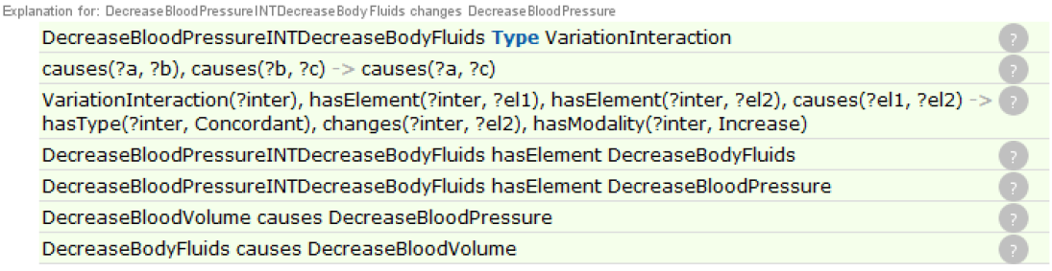

Figure 2

As regards the temporal analysis, we provide a graphic representation of the interactions, in which effects are represented as intervals in a timeline (see Figure 3, taken from [[2]](https://www.zotero.org/google-docs/?nriUbN)). Such a representation makes explicit the possible overlap (and consequently the temporal interaction) between them.

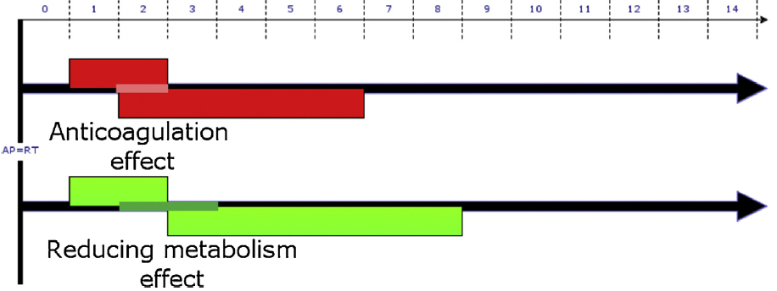

Figure 3

As regards interaction management, the selection of the management option does not require explanation, since it is made directly in collaboration with physicians. On the other hand, when some parameters have to be selected, the explanation mechanism depends on the reasoner (see Figure 1) exploited to implement the management option:

* where the reasoner is the Goal Based Planner, the (possible) alternatives are retrieved from the knowledge model by searching the actions with effects “similar” (the same ones, or causing them) to a set of intentions. In such a case, a piece of the ontological model can be shown to physicians to explain the alternatives (such a view is not yet implemented in GLARE-SSCPM)
* where the reasoner is the Temporal one, a GUI similar to the one in Figure XX2 (see [[2]](https://www.zotero.org/google-docs/?etvcUi)) shows how the temporal intervals of the interacting effects (and consequently their overlap) change with the proposed modifications
* the Backward CIG Navigator performs a simple navigation of the CIGs. Consequently, it does not require any explanation.

**C4**: Alternative mitigation strategies for a single interaction

*For example, if there are more than one possible mitigation strategies, are they identified and presented.*

*Implemented (Y/N)*: Y

*Brief description*: for each detected interaction, GLARE-SSCPM takes into account the eight management options. Moreover, each management option can be applied to the CIGs in different ways, depending on the selected parameters. This allows physicians to select among a very broad range of alternative mitigation strategies. Consider, for instance, the case study described in [[4]](https://www.zotero.org/google-docs/?6LAFIk),describing a patient suffering from peptic ulcer and venous thromboembolism. To manage the interaction between warfarin and amoxicillin, first the physician decides to apply the “safe alternative” management option and to select an alternative anticoagulant in the CIG for venous thromboembolism. However, the alternative drug (fondaparinux) also interacts with amoxicillin. As a consequence, following the hypothesize-and-test methodology offered by GLARE-SSCPM, the physician decides to select an alternative management option for warfarin and amoxicillin (“replanning”), replacing warfarin with the alternative drug aspirin.

## Part 3: Implementation of the Case Studies

Please describe how each of the clinical case studies was implemented.

For each of the case studies, please use the format outlined below when reporting the implementation.

### **Case 1**

### Input (1 page):

* Show the encoded CIGs required to solve the case in your approach formalism

The TIA CIG in GLARE. All the six plans (i.e. composite actions) are executed in parallel

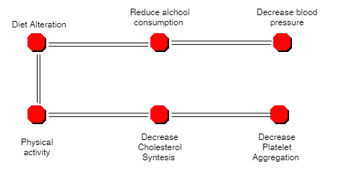

The graph which defines the plan Decreased Platelet Aggregation 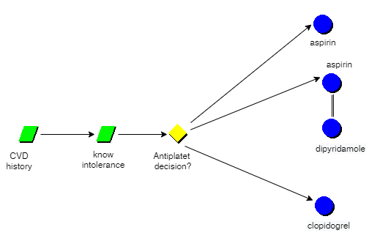

The DU CIG

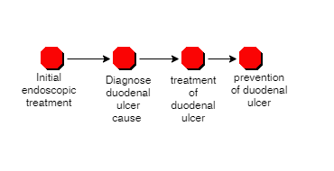

The first part of graph of Initial endoscopic treatment plan

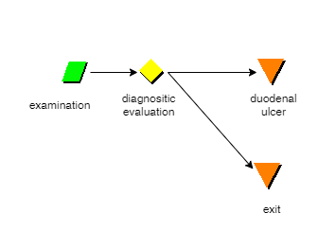

The graph of plan prevention of duodenal ulcer:

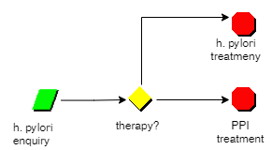

The OSTEO CIG

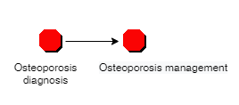

the graph of the plan Osteoporosis diagnosis

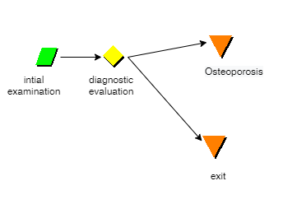

the graph of the plan Osteoporosis management

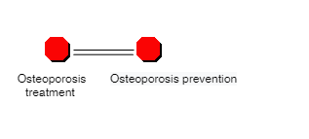

the graph of the plan Osteoporosis prevention

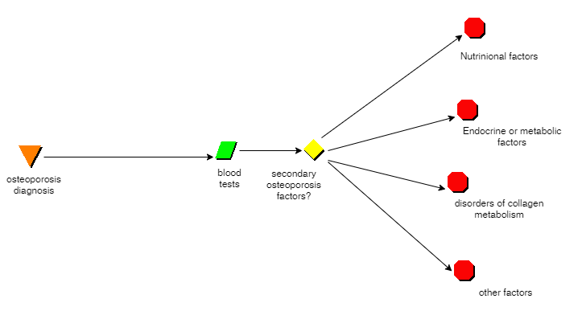

META-GLARE a CIG is represented as an XML document and then stored in a PostgreSQL dbms

* Show the encoded patient data

In META-GLARE, patient data are represented as tuples <data, attribute, value, timestamp> (the current implementation of timestamp record date and time of day. The patient data are stored in a PostgreSQL database.

Example of a patient data for Case 1, before the osteoporosis problem is discovered (Notably 1111111111111111 is symbolic id of our patient).

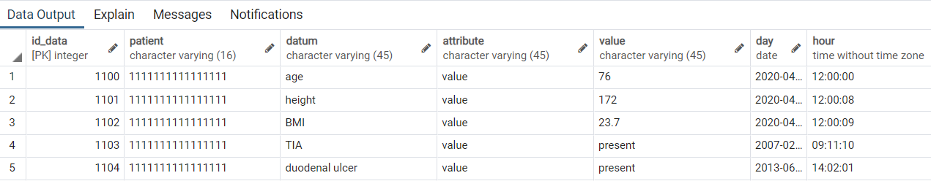

* If applicable, show how adverse interactions (features A1-A7) were encoded a-priori

Not applicable

* If applicable, show/reference the encoding of additional domain knowledge

The domain knowledge maintained by the Knowledge Manager module is modeled in OWL. We provide a first-order-logic representation of the part useful for the example:

isA(aspirin_tia,aspirin), isA(aspirin,NSAID), isA(aspirin,PlateletAggregatorInhibitor), aimsTo(aspirin_tia,DecreaseStrokeRisk), hasEffect(PlateletAggregatorInhibitor,DecreaseClots), causes(DecreaseClots,DecreaseStrokeRisk), hasEffect(NSAID,DecreaseProstaglandin), causes(DecreaseProstaglandin,IncreaseGastricAcidity), causes(IncreaseGastricAcidity,IncreaseGastricUlcer), focusOn(IncreaseGastricUlcer,GastricUlcer), hasModality(IncreaseGastricUlcer,Increase),

isA(omeprazole_du,omeprazole), isA(omeprazole,ProtonPumpInhibitor), hasEffect(ProtonPumpInhibitor,DecreaseCalciumAbsorption), hasEffect(ProtonPumpInhibitor,DecreaseGastricAcidity), causes(DecreaseCalciumAbsorption,IncreaseOsteoporosis), focusOn(IncreaseOsteoporosis,Osteoporosis), hasModality(IncreaseOsteoporosis,Increase),

isA(clopidogrel,PlateletAggregatorInhibitor)

The remaining knowledge, used to retrieve alternative actions for interaction management, is omitted for the sake of brevity. SWRL rules used for explanation:

Interaction(?inter), hasElement(?inter, ?el1), hasElement(?inter, ?el2), Valorization(?el2), valorizes(?el2, ?attr), hasEffect(?el1, ?eff1), focusOn(?eff1, ?attr) -> StatusInteraction(?inter)

StatusInteraction(?inter), hasElement(?inter, ?el1), hasElement(?inter, ?el2), Valorization(?el2), valorizes(?el2, ?attr), hasEffect(?el1, ?eff1), focusOn(?eff1, ?attr) -> changes(?inter, ?attr)

StatusInteraction(?inter), hasElement(?inter, ?el1), hasElement(?inter, ?el2), Valorization(?el2), valorizes(?el2, ?attr), hasValue(?el2, ?value), High(?value), hasEffect(?el1, ?eff1), focusOn(?eff1, ?attr), hasModality(?eff1, ?mod1), Increase(?mod1) -> hasType(?inter, Concordant)

### Processing (1 page):

* If applicable, explain how relevant interactions were (automatically) identified (features A1-A7)

**Aspirin and Gastric Ulcer (detection A1).** The starting of the DU CIG adds the facts {valorization(HighGastricUlcer),valorizes(HighGastricUlcer,GastricUlcer),hasValue(HighGastricUlcer,High)} to the knowledge base maintained by the Knowledge Manager module. Given such facts and the domain knowledge, taking into account that aspirin is a NSAID and NSAIDs may cause (an increasing of) gastric ulcer, the Interaction Detection module infers a *status interaction* between the action aspirin_tia and the gastric ulcer status of the patient. Such an interaction is automatically detected as soon as the user physician decides to check interactions between a part of the TIA CIG containing aspirin and the DU CIG. The explanation for such an interaction can be shown to physicians as shown in Figure 4.

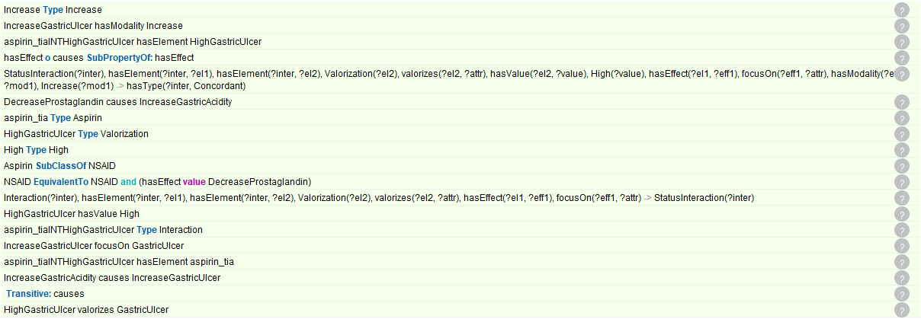

Figure 4. Explanation for the interaction between aspirin and gastric ulcer.

**Omeprazole and Osteoporosis (detection A1).** The starting of the OSTEO CIG adds the facts {valorization(HighOsteoporosis),valorizes(HighOsteoporosis,Osteoporosis),hasValue(HighOsteoporosis,High)} to the knowledge base maintained by the Knowledge Manager module. Given such facts and the domain knowledge, taking into account that omeprazole is a PPI and PPIs may cause (an increasing of) osteoporosis, the Interaction Detection module infers a *status interaction* between the action omeoprazole_du and the osteoporosis status of the patient.

**A3 and A4.** The GLARE representation formalism does not cope with cancel actions (e.g., “stop the administration of drug A”). Thus, the recommendations of stopping Aspirin and Omeprazole are not encoded in our CIGs, but they are part of the application of the management options proposed to manage the (identified) interactions, see below.

**Aspirin and Omeprazole (detection A4).** When the user physician decides to analyze, with the help of the focusing facility of the Interaction Detection module, the “prevention of duodenal ulcer” of the DU CIG, among the others[2], the system also detects a *variation interaction* between aspirin and omeprazole, of type “Opposite”. Indeed they both have effect on the attribute “GastricAcidity”, but with opposite modalities (“Increase” and “Decrease”).

**A7 multiple interactions.** The first detected interaction is the one between the TIA and the DU CIGs. Such an interaction is managed in isolation (see below), without considering the other one (see below). Then, the two CIGs continue their execution. At a later time, when the second interaction (between DU and OSTEO) is detected, the physician can decide to:

* manage it in isolation and then check the consistency of all the managements by exploiting the Conciliation module or
* (if the first management has caused the second interaction) revise the previous managements

In the following, we will show both the options as alternative solutions.

* Explain how relevant interactions were (automatically) mitigated (features B1-B8)

Notice. The two following managements obtain the same result, however they can be applied in two different configurations. The first one can be exploited in case the CIG for DU is actually executed and it prescribes, among the others, omeprazole. In such a case, it is not needed to add omeprazole as an “external” mitigating action, because it already appears in a CIG and one only needs to execute it. The second management can be applied if a CIG for DU is not executed, but an interaction between the aspirin and the patient’s status (gastric ulcer) is detected. In such a case, omeprazole has to be added to the CIGs by using the knowledge of GLARE-SSCPM.

**Aspirin and Omeprazole (management B8 - interaction alignment).** To manage the given interaction, the physician may decide among the eight management options provided by GLARE-SSCPM (plus the “no management” one, if she decides that the interaction does not deserve to be managed). In such a case, we suppose that she selects the “interaction alignment” one to ensure that the interaction between aspirin and omeprazole, which mitigates the effect of aspirin on the ulcer, actually occurs. As a consequence, the Interaction Management module of GLARE-SSCPM adds constraints to the DU CIG to ensure that:

* Omeprazole is actually executed
* omeprazole is executed during the execution of aspirin, or rather in a time ensuring the overlap between the effect of aspirin and the one of omeprazole (in the given case, the two conditions correspond).

**Aspirin and Gastric Ulcer (management B1 - interaction mitigation).** The exact result of the previous management between aspirin and omeprazole can be obtained by managing the interaction between aspirin and gastric ulcer, in case omeprazole is not contained in any CIG. In such a case, to mitigate the given interaction, the physician may decide to apply the “interaction mitigation” management option. In such a case, the Interaction Management module retrieves, from the knowledge base, all the actions with an interaction of type “Opposite” (or “Discordant”) with respect to the effect of the managed interaction (having the effect of increasing the gastric ulcer). Among the proposed actions (see Figure 5), also the PPI drugs are proposed, and the physician can decide to add omeprazole as a mitigating action. Even in this case, the facilities provided by the Temporal Reasoner module are exploited to ensure the temporal overlap between the effect of aspirin and the one of omeprazole.

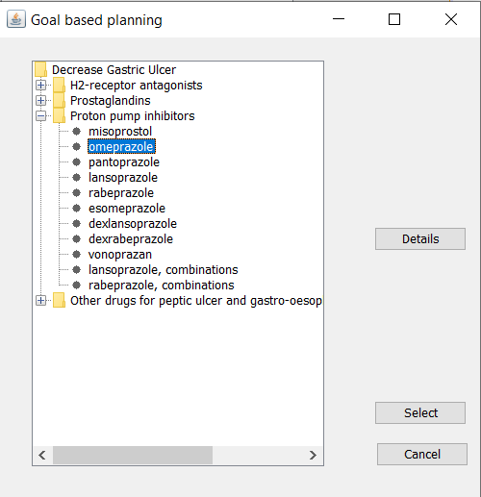

Figure 5. Alternative actions found by the Goal Based Planner to mitigate the interaction between Aspirin and Gastric Ulcer.

Now, we show three alternative scenarios: the first one reproduces the “suggested” solution for this case (see the case definition), while the following ones produce alternative solutions.

**(i) Aspirin and Gastric Ulcer (management B4 - replanning).** We suppose that, at a later time with respect to the application of the previous managements, the interaction between omeprazole and osteoporosis is detected. The physician may decide to cancel the administration of omeprazole. Considering the previous managements, the administrations of omeprazole are related to the ones of aspirin. Thus, the physician decides to further modify the management of the interaction between aspirin and gastric ulcer by selecting the “replanning” management option and avoid the execution of aspirin. The Interaction Management module retrieves, from the knowledge base, all the actions with effect “DecreaseStrokeRisk” (i.e., the intention of aspirin_tia). Among them, all the platelet aggregation inhibitors are proposed to the physician. In our simulation, we suppose that she selects clopidogrel. Since aspirin is already under execution, the application of the management involves the stopping of the aspirin administration and the starting of the clopidogrel one. The result is shown to the physician as in Figure O1.1.

**(ii) Omeprazole and Osteoporosis (management B4 - replanning).** As an alternative, the physician may select to directly manage the interaction between omeprazole and osteoporosis. In particular, she can decide to replace omeprazole with an alternative therapy, achieving the same intention (“DecreaseGastricAcidity”), but not interacting with osteoporosis. The Interaction Management module allows her to select among them and, in our case, we suppose that the physician decides to replace omeprazole with a h2 receptor antagonist. Since omeprazole is already under execution, the application of the management stops it and adds, as following action, a plan containing the choice of the h2 receptor antagonist to be administered and its administrations. The result is shown to the physician as in Figure O1.2.

**(iii) Omeprazole and Osteoporosis (management B1 - interaction mitigation).** As a further alternative, the physician may select to manage the interaction between omeprazole and osteoporosis with the “interaction mitigation” option. The Interaction Management module retrieves, from the knowledge base, all the actions mitigating the given interaction (i.e., the ones decreasing osteoporosis). Among them, also alendronate, risedronate, zoledronic acid, teriparatide, or denosumab are retrieved. In such a case, the physician can select one of them and add it to the CIGs.

* If applicable, explain how other relevant features were realized (features C1-C4)

**C1 Patient preferences and/or patient burden.** As shown above, GLARE-SSCPM allows physicians to select among several alternatives to manage interactions (management options and parameters). Such choices can be taken in accordance with the patient, to meet her preference. For instance, let's consider the alternative scenarios (i)-(iii) above: the first one (replacing aspirin with clopidogrel) is more suitable for patients preferring a low number of medications, in spite of changing the antiplatelet drug. On the other hand, the third solution is the most conservative one: it maintains all the given medications, but it adds another one.

**C3 Explanation.** In the case at hand, we show the explanations provided by GLARE-SSCPM both for qualitative (i.e., non-temporal) interaction detection (see Figure 4) and for the selection of alternatives (see Figure 5) in interaction management.

**C4 Alternative mitigation strategies for a single interaction.** As explained above, GLARE-SSCPM allows physicians to select among several options. Each option can be further refined by selecting a set of parameters, and the available choices for each parameter mainly depend on the knowledge contained in the knowledge model. As a consequence, listing all the possible alternatives for each interaction is not suitable. However, it is easy to notice that managements (ii) and (iii) are a good example of alternative mitigation strategies (management options) for the same interaction. Moreover, considering the parameters to be chosen and the knowledge added for the specific example, we have two possible h2 receptor antagonist drugs for the replanning of management (ii) and 5 possible drugs for the mitigation of management (iii), resulting in 7 alternative mitigation strategies for a single interaction.

* Explain which parts of the processing are generic and which need to be hardwired for the case[3]

In the case at hand, all the processing algorithms and the domain knowledge used are generic.

### Output (1 page):

* Show and explain how the result of the processing is represented

The GUI shows the two CIGs (focused on the relevant parts) and in the middle the actions (eventually) added to manage the interaction. The CIGs are presented with the modification prescribed by the management (e.g. some actions could be cancelled). Moreover the GUI shows the control flows relations and the temporal constraints between the actions in the middle box and the actions in the CIG

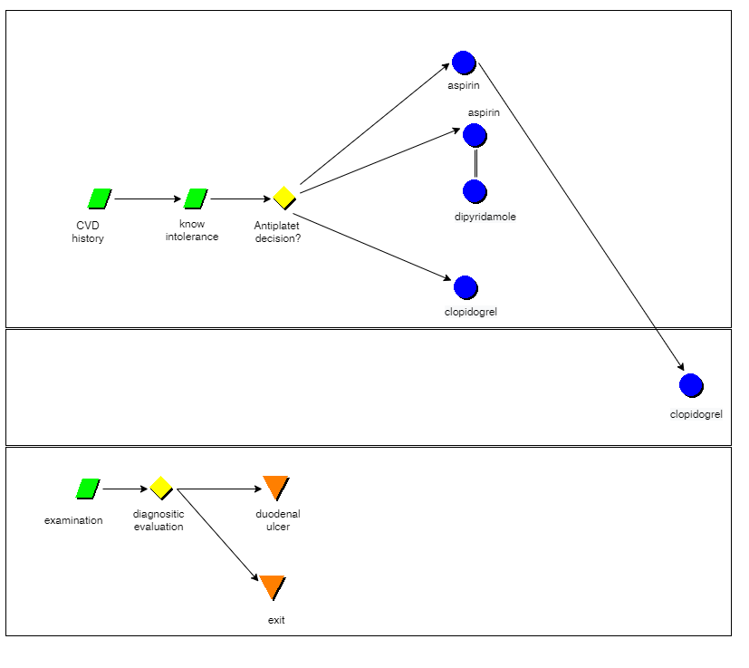

FIG O1.1

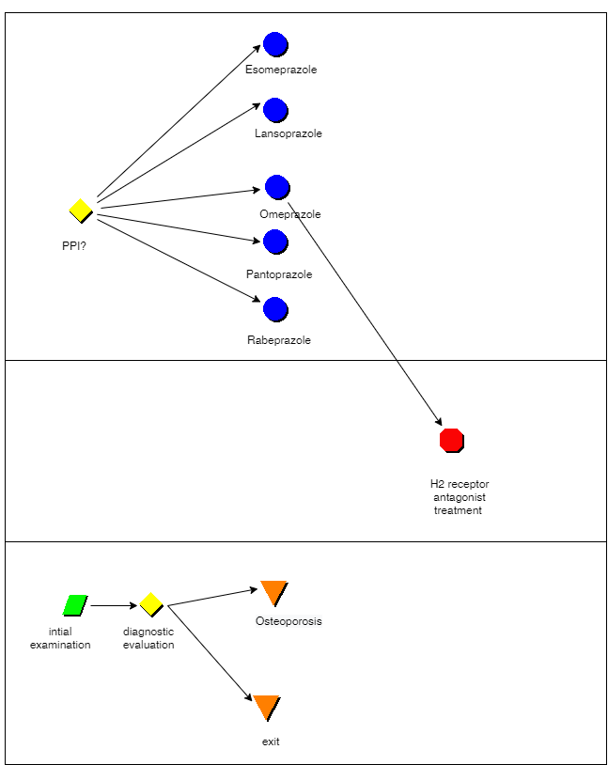

FIG O1.2

* Show and explain what user interactions were involved in the use case

The interactions between the user physician and the system have been explained for each task.

* Explain any additional considerations.

Not applicable.

### **Case 2**

### Input (1 page):

* Show the encoded CIGs required to solve the case in your approach formalism

The CKD CIG

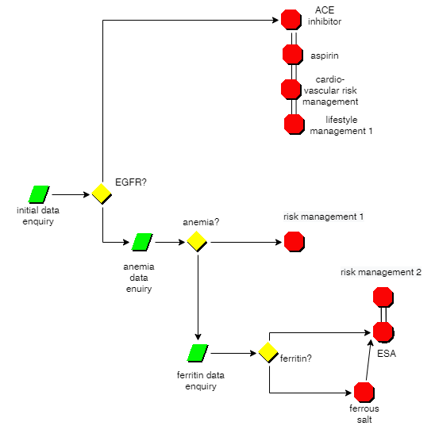

The plan metabolism management 1 (the plan metabolism management 2 is defined in similar way)

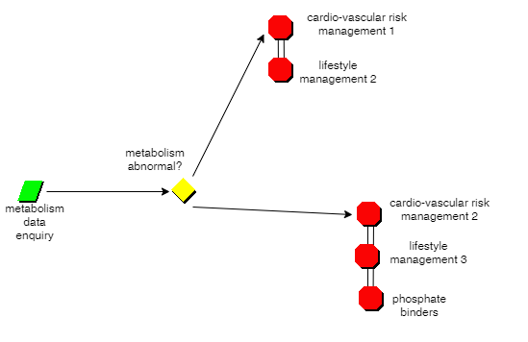

The HTN CIG

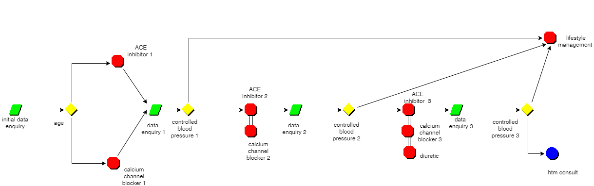

The AFIB CIG

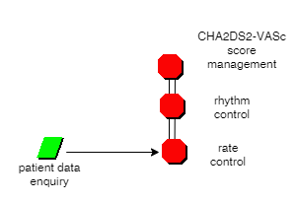

The plan CHA2DS2 -Vasc score management

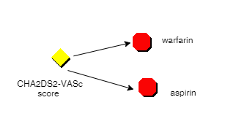

The rate control therapy plan

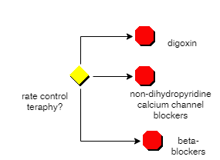

The rhythm control therapy plan

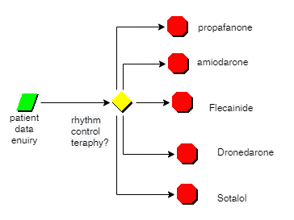

* Show the encoded patient data

The patient data are stored in a PostgreSQL database (for details see discussion in Case 1).

* If applicable, show how adverse interactions (features A1-A7) were encoded a-priori

The interaction between amiodarone and CKD, not inferrable from general knowledge, has been imported in the knowledge model as follows:

StatusInteraction(amiodaroneINTLowRenalFunction), hasElement(amiodaroneINTLowRenalFunction,amiodarone_afib), hasElement(amiodaroneINTLowRenalFunction,LowRenalFunction),

changes(amiodaroneINTLowRenalFunction,DecreaseBloodPressure), hasModality(amiodaroneINTLowRenalFunction,Decrease)

* If applicable, show/reference the encoding of additional domain knowledge

The domain knowledge maintained by the Knowledge Manager module is modeled in OWL. We provide a first-order-logic representation of the part useful for the example:

isA(aspirin_ckd,aspirin), isA(aspirin,PlateletAggregatorInhibitor), aimsTo(aspirin_ckd,DecreaseClots), hasEffect(PlateletAggregatorInhibitor,DecreaseBloodCoagulation), hasEffect(PlateletAggregatorInhibitor,DecreaseClots),

isA(warfarin_afib,warfarin), isA(warfarin,PlateletAggregatorInhibitor)

isA(beta-blockers_afib,BetaBlockingAgent) hasEffect(BetaBlockingAgent,DecreaseBloodPressure)

isA(ace-inhibitor_htn3,ACEinhibitor) hasEffect(ACEinhibitor,DecreaseBloodPressure)

aimsTo(amiodarone_afib,DecreaseArrhythmia)

The remaining knowledge, used to retrieve alternative actions for interaction management, is omitted for the sake of brevity.

### Processing (1 page):

* If applicable, explain how relevant interactions were (automatically) identified (features A1-A7)

**Warfarin and aspirin (detection A2/A5).** The interaction between warfarin and aspirin is detected (by the Interaction Detection module) as soon as the AFIB CIG starts. Indeed, warfarin and (low-dose) aspirin are both platelet aggregation inhibitors (i.e., with the effect of decreasing blood coagulation status). As a consequence, a *drug interaction* is detected between them, of type “Concordant”. Since both the treatments have long duration, a temporal analysis is not needed in this case.

**Beta blockers and ACE inhibitors (detection A2).** The interaction between ACE inhibitors and Beta blockers can be detected by the physician by focusing on the part of the HTN CIG currently under execution (prescribing ACE inhibitors, calcium channel blockers and diuretics) and the rate control therapy part of the AFIB CIG. Indeed, both the two (categories of) actions have interacting/similar effects (e.g., they both decrease blood pressure). As a consequence, a *drug interaction* is detected between them by the Interaction Detection module, of type “Concordant''. Please notice that, at such a level of detail, the same kind of interaction is detected also between Beta blockers (AFIB) and calcium channel blockers or diuretics (HTN).

**Amiodarone and CKD (detection A1).** (please notice that in such a case the interaction is not inferred, but retrieved from the knowledge base) We suppose that after 4 weeks from the onset of atrial fibrillation, the physician decides to perform interaction detection between the rhythm control therapy plan (part of AFIB) and a part of the CIG for CKD. As a consequence, the Interaction Detection module retrieves a drug interaction between amiodarone and CKD.

* Explain how relevant interactions were (automatically) mitigated (features B1-B8)

**Warfarin and aspirin (A5 - intention alignment).** Since the interaction is of type “Concordant” and, in particular, warfarin also reaches all the intentions of aspirin, we suppose that the user physician decides to manage it by applying a “duplicate removal” management option. In particular, the Interaction Management module suggests to remove aspirin from the CKD CIG and to maintain warfarin in the AFIB CIG. Since aspirin is already started, it is stopped and temporal constraints are added to the CIGs to ensure that warfarin starts as soon as aspirin is stopped.

**Beta blockers and ACE inhibitors (B5 - safe alternative).** To manage the interaction between ACE inhibitors (currently administered for HTN) and Beta blockers (not already administered for AFIB), the physician decides to apply a “safe alternative” management option. In particular, the Interaction Management module navigates backward both the CIGs and retrieves the first therapeutic decisions before the interacting actions. In particular, it does not retrieve any therapeutic decision for the HTN CIG (indeed, all the preceding decisions are diagnostic) and the “rate control therapy?” one for AFIB. As a consequence, the only way to avoid the interaction, is to not select the path of Beta blockers in the “rate control therapy?” decision. Such a constraint is added to the AFIB CIG that, in practice, removes such the action from the CIG.

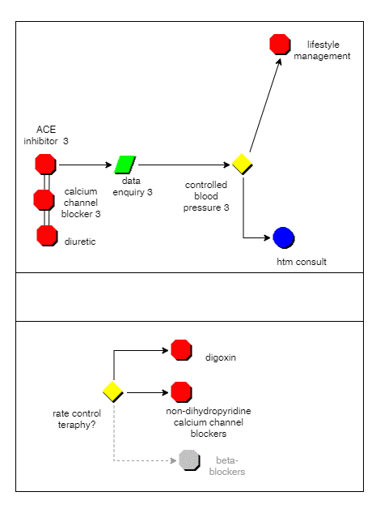

The following two managements of the interaction between amiodarone and CKD condition are alternative, and their application depends on when (in the CIG execution) the interaction is managed: (i) can be applied before the “rhythm control therapy?” is taken, (ii) must be applied after such a decision.

**(i) Amiodarone and CKD (B5 - safe alternative).** The management of the interaction between amiodarone (to be administered for AFIB) and the CKD condition is similar to the previous one. Indeed, also in this case the user physician decides to apply the “safe alternative” option. The Interaction Manager module retrieves, from the AFIB CIG (the CKD status cannot obviously be avoided), the “rhythm control therapy?” decision. Then, a constraint is added to the CIG to avoid the path of amiodarone. As a consequence, such a path cannot be selected in the current execution.

(ii) **Amiodarone and CKD (B4 - replanning).** If the interaction is managed after amiodarone is selected as therapy for the patient, the physician needs to manage such an interaction with the “replanning” management option. Thus, the Interaction Management module retrieves, from the knowledge model, all the actions achieving the intentions of amiodarone (i.e., to decrease arrhythmia) in the AFIB CIG. Among them (see class C01B in ATC), also propafenone is proposed to the user physician and she selects such a drug to replace amiodarone. As a consequence, the Interaction Management module replaces amiodarone with propafenone in the AFIB CIG.

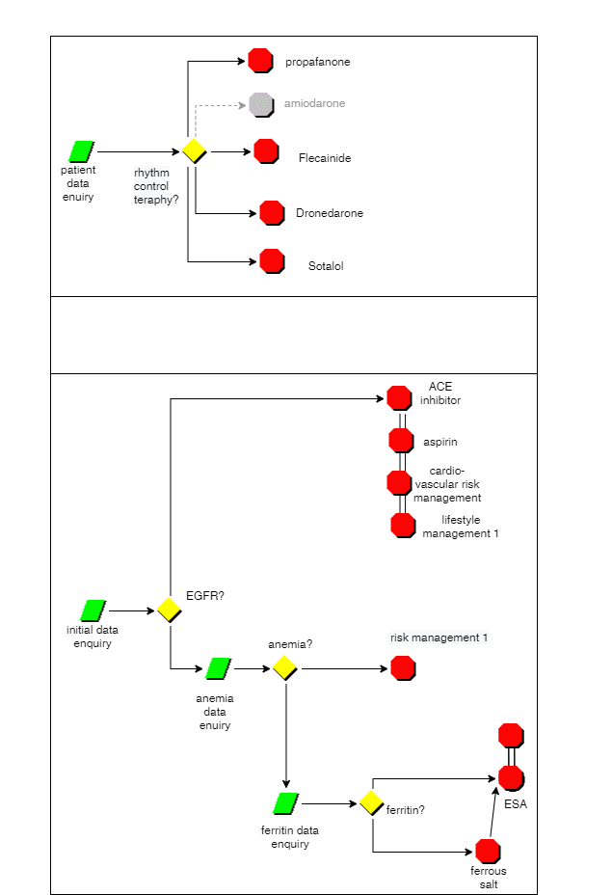

* If applicable, explain how other relevant features were realized (features C1-C4)

**C1: Patient preferences and/or patient burden.** We suppose that the patient prefers avoiding warfarin treatment in order to avoid a regular checking of the INR level. In GLARE-SSCPM such a facility is not directly supported. However, the patient and the physician can exploit the Goal Based planner of GLARE-SSCPM to retrieve, from the knowledge base, a plan achieving the same intentions of warfarin (i.e., of preventing blood clots), but not requiring INR monitoring. In such a case, at most a list containing antithrombotic agents (see ATC class B01A - among them apixaban) is proposed to them. Thus, they can select an alternative (or, a category of alternatives) to warfarin.

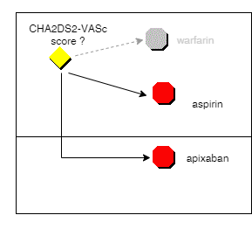

**C3: Explanation of the mitigation strategy(ies).** Explanation of interaction detection and management can be performed as shown for case 1.

**C4: Alternative mitigation strategies for a single interaction.** As shown for case 1, several different management strategies are possible for each interaction. For example, in the current case, for management (ii), all the proposed alternatives (see class C01B in ATC) can be considered as alternative managements for the same interaction. Please notice, moreover, that the “safe alternative” management option does not force physicians to make a specific choice in a decision, but it excludes some options in case of (potential) interaction. As a consequence, all the remaining options of the decision can be still selected by the physician.

* Explain which parts of the processing are generic and which need to be hardwired for the case[4]

In the case at hand, all the processing algorithms and the domain knowledge used are generic, except the interaction between amiodarone and CKD, which needed to be inserted into the knowledge base.

### Output (1 page):

* Show and explain how the result of the processing is represented

The results of the processing are shown below the description of each management.

* Show and explain what user interactions were involved in the use case

The user interactions are described above.

* Explain any additional considerations.

Not applicable.

### Case 3

### Input (1 page):

* Show the encoded CIGs required to solve the case in your approach formalism

Relevant part of VTE CIG

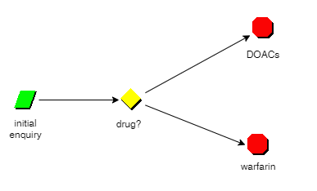

THE UTI CIG

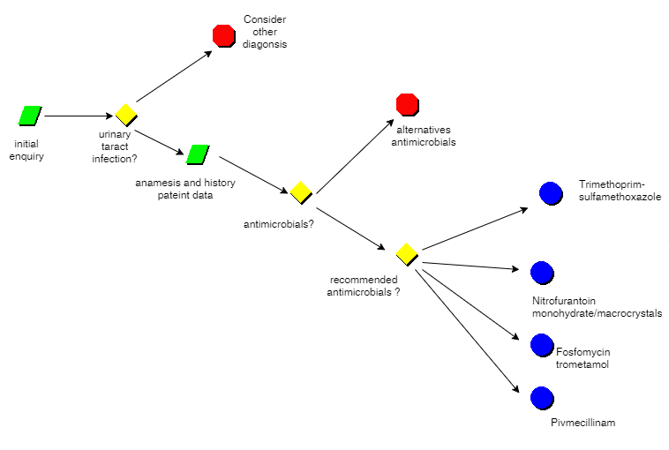

* Show the encoded patient data

The patient data are stored in a PostgreSQL database (for details see discussion in Case 1)

* If applicable, show how adverse interactions (features A1-A7) were encoded a-priori

Not applicable

* If applicable, show/reference the encoding of additional domain knowledge

isA(TMP/SMX_uti,sulfamethoxazole), isA(TMP/SMX_uti,trimethoprim)

hasEffect(sulfamethoxazole,DecreaseWarfarinMetabolism),

isA(warfarin_vte,warfarin), isA(warfarin,PlateletAggregatorInhibitor), hasEffect(PlateletAggregatorInhibitor,DecreaseBloodCoagulation),

SWRL rules:

Interaction(?int), hasElement(?int,?el1), hasElement(?int,?el2), hasEffect(?el1,?eff1), hasModality(?eff1,?mod1), Decrease(?mod1), focusOn(?eff1,?attr1), Metabolism(?attr1), metabolismOf(?attr1,?el2), hasEffect(?el2,?eff2) -> changes(?int,?eff2), hasModality(?int,Increase)

### Processing (1 page):

* If applicable, explain how relevant interactions were (automatically) identified (features A1-A7)

**Warfarin and TMP/SMX (detection A2).** When interaction detection is performed between a part of the VTE CIG containing warfarin and a part of the UTI CIG containing TMP/SMX, a *drug interaction* between the two drugs is inferred by the Interaction Detection Module. Indeed, from the knowledge model, we have that TMP/SMX is a sulfamethoxazole, and sulfamethoxazole decreases the metabolism of warfarin. Given the rule asserting that a decrease of the metabolism of a drug produces an increase of its effects, the module infers that the detected interaction causes an increase in the anticoagulant effect of warfarin. As regards the temporal analysis of the interaction, since there is no clinical evidence about the temporal extension of the effects of sulfamethoxazole on the warfarin metabolism, we decided to coincide them (in the knowledge model) with an overestimated interval starting with the sulfamethoxazole administration and ending one day after its suspension. As a consequence, the interaction occurs during such an interval[5].

* Explain how relevant interactions were (automatically) mitigated (features B1-B8)

**Warfarin and TMP/SMX (management B2 - dosage adjustment).** To manage the interaction between warfarin and TMP/SMX, among the proposed management options, the physician selects the “dosage adjustment”. Since the interaction between warfarin and TMP/SMX has, as effect, the increase of the anticoagulant effect of warfarin, the Interaction Management module suggests physician to decrease the dosage of warfarin. In particular, the physician decides to decrease warfarin by 10%.

**Warfarin and TMP/SMX (management B3 - interaction mitigation).** Moreover, the physician decides to apply another management to the interaction. In particular, she decides to apply the “effect monitoring” one. Since, considering the interaction detection and the knowledge model, the interaction changes the anticoagulant effect of warfarin, and the anticoagulant effect focuses on the blood coagulation status, the Interaction Management module retrieves, from the knowledge model, all the query actions focusing on such an attribute. Among them, the physician selects the “INR monitoring” one. The control flow relations of the “INR monitoring” plan are calculated by the Temporal Reasoner module in order to execute it during the drug interaction time window (i.e., between the TMP/SMX starting and one day after its ending). Then, exploiting the GUI provided by the Interaction Management module, the physician can adjust the execution of the monitoring action. In particular, to reach the suggested solution for the case at hand, we suppose that she selects to start the monitoring three days after the starting of TMP/SMX.

* If applicable, explain how other relevant features were realized (features C1-C4)

**C1 Patient preferences and/or patient burden.** As regards the choice of the anticoagulant therapy, since “drug?” is, in GLARE, modeled as a therapeutic decision, the patient’s and physician’s preferences are involved in the decision. As a consequence, the choice of the anticoagulant therapy is directly supported by GLARE.

**C3: Explanation of the mitigation strategy(ies).** Explanation of interaction detection and management can be performed as shown for case 1.

**C4: Alternative mitigation strategies for a single interaction.** As shown for case 1, several different management strategies are possible for each interaction. For example, in the current case, the “replanning” management option can be applied to the interaction between warfarin and TMP/SMX, in order to retrieve a non-interacting alternative to TMP/SMX. Moreover, the “safe alternative” management option can be applied, to exclude TMP/SMX as possible choice of the “recommended antimicrobials?” decision of the UTI CIG. In such a case, also the interactions between warfarin and the other recommended antimicrobials should be considered (and managed, eventually through the “safe alternative” option). In such a case, exploiting the Conciliation module and the constraints added for the management of each interaction, the only Nitrofurantoin monohydrate/macrocrystals treatment would be left as available therapy.

* Explain which parts of the processing are generic and which need to be hardwired for the case[6]

In the case at hand, all the processing algorithms and the domain knowledge used are generic.

### Output (1 page):

* Show and explain how the result of the processing is represented

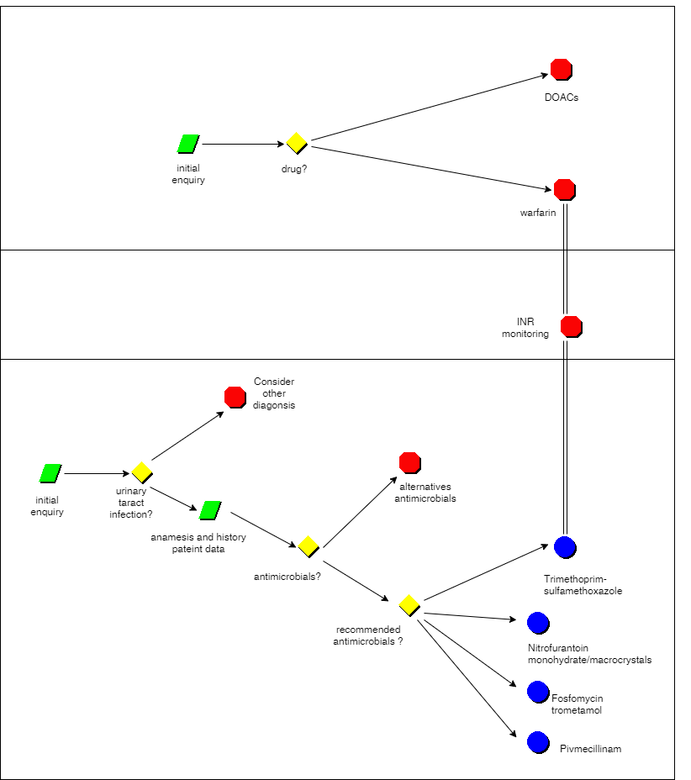

FIG O3.1

* Show and explain what user interactions were involved in the use case

The user interactions are described above.

* Explain any additional considerations.

Not applicable.

### Case 4

### Input (1 page):

* Show the encoded CIGs required to solve the case in your approach formalism

the relevant part of Drug-eluting Stent CIG

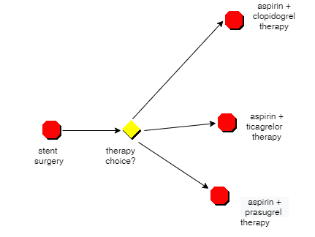

The aspirin+clopidrogel plan

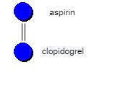

The lung cancer CIG

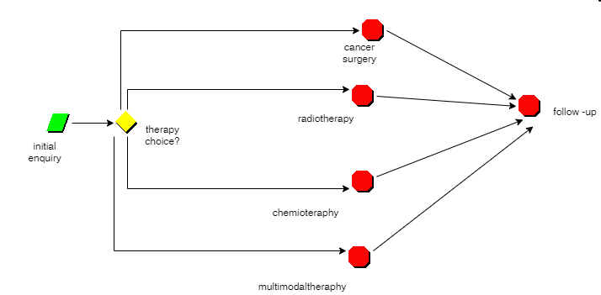

* Show the encoded patient data

The patient data are stored in a PostgreSQL database (for details see discussion in Case 1)

* If applicable, show how adverse interactions (features A1-A7) were encoded a-priori

Not applicable

* If applicable, show/reference the encoding of additional domain knowledge

isA(clopidogrel_st,clopidogrel), isA(clopidogrel,PlateletAggregatorInhibitor), aimsTo(clopidogrel_st,DecreaseClots), hasEffect(PlateletAggregatorInhibitor,DecreaseBloodCoagulation), causes(DecreaseBloodCoagulation,IncreaseBleeding)

isA(cancer-surgery_lu,surgery), hasEffect(surgery,IncreaseBleeding)

isA(tirofiban,PlateletAggregatorInhibitor), isA(ticagrelor,PlateletAggregatorInhibitor), isA(prasugrel,PlateletAggregatorInhibitor)

Temporal Constraints:

* clopidogrel_start - DecreaseClots_start in [0,0] days (i.e., the effect starts the day of administration)
* clopidogrel_end - DecreaseClots_end in [1,5] days (i.e., the effect ends between 1[7] and 5 days after the suspension)
* clopidogrel_start - IncreaseBleeding_start in [0,0] days
* clopidogrel_end - IncreaseBleeding_end in [1,5] days
* surgery_start - IncreaseBleeding_start in [0,0] days
* surgery_end - IncreaseBleeding_end in [0,1] days
* the intention of clopidogrel_st (DecreaseClots) in the ST CIG must last in interval [-60,300]
* tirofiban_start - DecreaseClots_start in [0,0] hours[8]
* tirofiban_end - DecreaseClots_end in [4,8] hours

### Processing (1 page):

* If applicable, explain how relevant interactions were (automatically) identified (features A1-A7)

**Clopidogrel and cancer surgery (detection - A1).** When the physician performs interaction detection between the part of the Drug-eluting Stent CIG containing clopidogrel and the part of the lung cancer CIG containing surgery, the Interaction Detection module infers an interaction between clopidogrel and the surgery. Indeed, the drug has an antiplatelet effect that may affect (increase) the risk of bleedings and, following the knowledge model, also surgery increases the risk of bleedings. As a consequence, a variation interaction is inferred of type “Concordant”. Such an interaction needs to be temporally analyzed. In particular, exploiting the facilities of the Temporal Reasoner module of GLARE-SSCPM, the physician hypothesizes that the surgery will happen on a specific day (for simplicity, let us assume at day 0). Considering the log of executed actions, the temporal constraints in the CIGs and the temporal information contained in the knowledge model, the Temporal Reasoner module calculates if the interaction may occur in time (i.e., if the two interacting effects may overlap in time). The answer of the module is “”YES” (i.e., they certainly overlap in time). Such an overlap is explained to the physician as in Figure YY.

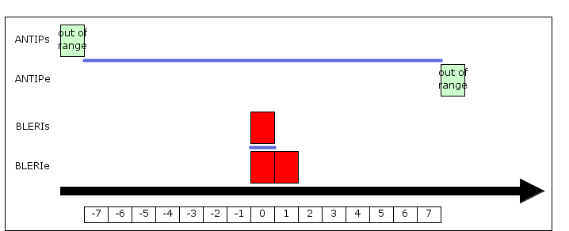

Figure YY. GLARE-SSCPM temporal representation of the interaction between the antiplatelet effect of clopidogrel and the risk of bleeding (effect of surgery).

In the Figure, each line represents the possible time of a specific time point[9] (start/end) of an effect (ANTIPs: start of the antiplatelet effect, ANTIPe: end of the antiplatelet effect, BLERIs: start of the risk of bleeding, BLERIe: end of the risk of bleeding). The lines between the start/end points represent the intervals of certainly occurrence of such an effect (i.e., the antiplatelet effect certainly occurs in an interval starting before the range of the analysis and ending after the range of the analysis, while the risk of bleeding - of surgery - certainly occurs at day 0).

Using the temporal constraints in the knowledge and in the log, and temporal reasoning, the module infers that the clopidogrel administrations that potentially interact with surgery are the ones performed in the interval [-5,+1] and the ones that certainly interact are the ones performed at days [-1,0]. Indeed, the first ones are the ones with the antiplatelet effect lasting at time 0 or 1, and the latter are the ones with effect lasting at time 0. For brevity, in the following, we adopt the notation [-5,-1,0,+1] to represent such intervals.

**Aspirin and cancer surgery (detection - A1).** An interaction can be detected between aspirin and cancer surgery. The interaction inference and analysis are the same shown for the interaction between clopidogrel and surgery and are omitted for the sake of brevity.

**Aspirin and tirofiban (detection - A5).** Once managed the interaction between clopidogrel and cancer surgery (see below), a new action (tirofiban) is added to the CIGs. However, if the physician decides to perform interaction detection in the part of the Drug-eluting Stent CIG containing aspirin and the added part containing tirofiban, an interaction between tirofiban and aspirin is detected. Indeed, they both decrease platelet aggregation.

* Explain how relevant interactions were (automatically) mitigated (features B1-B8)

**Clopidogrel and cancer surgery (management - B4 B5 B6 B7 replanning).** To manage the interaction between clopidogrel and surgery, we suppose that the physician decides to apply the “replanning” management option to replace the part of the clopidogrel treatment interacting with surgery (i.e., in the interval [-5,-1,0,+1]). The Interaction Management module retrieves from the knowledge base the actions achieving the same intentions of clopidogrel (i.e., prevent blood clots). Among the proposed actions, tirofiban and eptifibatide are listed. Then, the physician selects one of them (e.g., tirofiban). Since tirofiban has a more rapid onset of the effects, the Temporal Reasoner module, to replace clopidogrel in interval [-5,-1,0,+1], suggests administering it in the interval [-4,+1]. The physician approves such an interval, and decides to place the last tirofiban administration before the surgery at 4 hours of distance, and the first one before it at 2 hours of distance.

**Clopidogrel and cancer surgery (management - B2).** Finally, to compensate the low onset of the effect of clopidogrel, the physician decides to apply also a dosage adjustment to the drug in order to fasten the onset of the antiplatelet effect. For such a reason, clopidogrel dosage is augmented to 300mg for the first day of administration after the surgery.

* If applicable, explain how other relevant features were realized (features C1-C4)

**C1 Patient preferences and/or patient burden.** As shown above, GLARE-SSCPM allows physicians to select among several alternatives to manage interactions (management options and parameters). Such choices can be taken in accordance with the patient, to meet her preference. For instance, let's consider the interaction between clopidogrel and surgery. As regards the choice of the management option, the system does not force physicians (and patients) to manage each detected interaction: as a consequence, an alternative solution can be the one in which the dual antiplatelet therapy is not discontinued.

**C3: Explanation of the mitigation strategy(ies).** Explanation of interaction detection and management can be performed as shown for case 1.

**C4: Alternative mitigation strategies for a single interaction.** As discussed for case 1, several different management strategies are possible for each interaction. For example, in the current case, the physician is asked to select among several alternatives (retrieved from the knowledge base) to replace tirofiban. Moreover, besides the eight management options provided by the Interaction Management module, physicians can select to not manage an interaction (the “no management” option). In such a case, the clopidogrel therapy does not need to be discontinued. Moreover, considering the management option chosen above (i.e., the “replanning” one), it is worth stressing that tirofiban is not the only possible alternative to clopidogrel (see ATC category “B01”).

* Explain which parts of the processing are generic and which need to be hardwired for the case[10]

In the case at hand, all the processing algorithms and the domain knowledge used are generic.

### Output (1 page):

* Show and explain how the result of the processing is represented

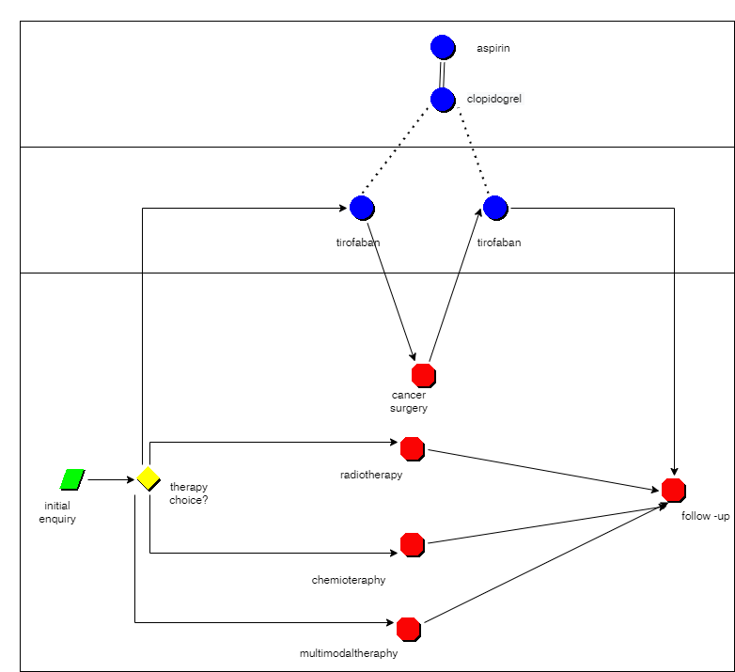

FIG 4.1 the dotted lines represent the new temporal constraints

* Show and explain what user interactions were involved in the use case

The user interactions are described above.

* Explain any additional considerations.

Case 4 is a good example of a situation in which, to better support physicians in the decision process, the temporal analysis of the interactions and their managements should be extended with probabilistic features. Indeed, even if temporal reasoning can cope with indeterminate time intervals (consider, e.g., the duration of an effect), often indeterminate times are not uniform: there is not the same probability that a fact (e.g., the ending of an effect) occurs in each time of the interval. For such a reason, in the last years (see, e.g., [[13]](https://www.zotero.org/google-docs/?3Hubbu)), we started to develop an extension of the Temporal Reasoner module able to cope also with probabilities.

1. Notably, features (1 -- 3) above are achieved by

   * organizing knowledge into three separate main modules: (i) CIGs (containing domain-specific evidence-based “procedural” knowledge about disease treatments; (ii) General Medical Knowledge (consisting og general CIG and domain-independent desclarative medical knowledge,including knowledge in well-known medical repositories such as SNOMED-CT and ATC), and (iii) domain independent procedures (e.g., replanning, temporal avoidance) to manage interactions.

   * providing general reasoning mechanisms operating on (the knowledge in) such modules.
2. Notice that all the treatments suggested in “PPI treatment” interact with aspirin, with similar modalities.
3. There are two aspects: (**1**) processing algorithm: in a generic approach, only models change across case studies, while a hardwired approach requires tweaking the algorithm for each case study; (**2**) domain knowledge: a mitigation strategy can be generic or hardwired: e.g., deriving which drug should replace another drug can come from a knowledge base or be hard-wired for each case study (e.g., based on guidelines). There can be degrees of generality as well, of course.
4. There are two aspects: (**1**) processing algorithm: in a generic approach, only models change across case studies, while a hardwired approach requires tweaking the algorithm for each case study; (**2**) domain knowledge: a mitigation strategy can be generic or hardwired: e.g., deriving which drug should replace another drug can come from a knowledge base or be hard-wired for each case study (e.g., based on guidelines). There can be degrees of generality as well, of course.
5. For the sake of brevity, the GUI for the temporal analysis is not shown in this document.
6. There are two aspects: (**1**) processing algorithm: in a generic approach, only models change across case studies, while a hardwired approach requires tweaking the algorithm for each case study; (**2**) domain knowledge: a mitigation strategy can be generic or hardwired: e.g., deriving which drug should replace another drug can come from a knowledge base or be hard-wired for each case study (e.g., based on guidelines). There can be degrees of generality as well, of course.
7. see, e.g., <https://pubmed.ncbi.nlm.nih.gov/10440417/>
8. Please notice that here, for the sake of simplicity, we express temporal constraints with different time units (i.e., days and hours). However, when performing temporal reasoning, all the constraints are converted at the smallest unit (i.e., hours in this case).
9. In the specific example, the starting and ending points of the antiplatelet effect of clopidogrel are out of range, since the effect starts and ends out of the temporal interval taken into account (i.e., [-7,7]).
10. There are two aspects: (**1**) processing algorithm: in a generic approach, only models change across case studies, while a hardwired approach requires tweaking the algorithm for each case study; (**2**) domain knowledge: a mitigation strategy can be generic or hardwired: e.g., deriving which drug should replace another drug can come from a knowledge base or be hard-wired for each case study (e.g., based on guidelines). There can be degrees of generality as well, of course.